**Assignment Name**: **Lab9:** (**Functions (V1))**

**Due date:** **11/9/2022, by 11:00 am.**

**Grade for assignment: 20** points

**Purpose:** Obtain experience in using Functions and realizing the importance of security in software development. Assignment accomplishes course learning objective “Create algorithmic solutions using functions”. Assignment also provides preparation for COSC236 course, and enhances skills needed in Information Technology (IT) and Computer Science industries.

**Skills:** Purpose of assignment is to help you practice the following skills.

-Ability to use Functions

-Ability to identify and correct buffer overflow

**Knowledge:** Become familiar with Functions and how to avoid buffer overflow.

**\*\*\*\*\*\*\*\*\*\*\*\*\*\*\*\*\*\*\*\*\*\*\*\*\*\*\*\*\*\*\*\*\*\*\*\*\*\*\*\*\*\*\*\*\*\*\*\*\*\*\*\*\*\*\*\*\*\*\*\*\*\*\*\*\*\*\*\*\*\*\*\*\*\*\*\***

**Place your Name(s) below:**

**Pairs work:** Please work in pairs. **One student in team should submit work**. Put **your first and last name on the assignment** and **your partner’s first and last name on the** assignment

**Note(s):**

1. All programs should be completed within the Visual Studio Code environment. There are guides in blackboard to start you off with Visual Studio Code.

**Partner 1: Name ______________________________________________**

**role (did the typing or read and review) _____________________________**

**Partner 2: Name ______________________________________________**

**role (did the typing or read and review)______________________________**

**Please note if one partner did not work on all problems.**

**Submission instructions:** All submissions will be done using blackboard. **Answers are to be submitted in a Microsoft word document.**

**Task**:

**Examples:** Refer to your notes from class, the Functions (Part1) PowerPoint, in class exercises and any available videos (located in Blackboard).

**Part1 (10 points):**

1. Type in the following program. Add a comment at the top to include your names and the date.

//*********************************************

//New Welcome Home Program

//This program prints a "Welcome Home" message

//*********************************************

#include <iostream>

using namespace std;

void PrintLines(int numLines); //prototype

int main()

{

PrintLines(2);

cout << "Welcome Home!" << endl;

return 0;

} // end of main method

//*********************************************

//PrintLines prints lines of astericks, where

//numlines specifiles how many lines to print

//*********************************************

void PrintLines(int numLines)

{

int line;

for (line = 0; line < numLines; line++)

{

cout << "******************************" << endl;

}

}

-Compile and Run.

1. Change the program so that it will continue to print 2 lines of asterisks before the welcome message and 4 lines of asterisks after the welcome message. (Note: **All lines of asterisks must come from the PrintLines function**.)
2. In the program: locate the Formal Parameters and label it as // Formal Parameters. Locate the Actual Parameters and label it as // Actual Parameters.
3. Is PrintLines an example of a void function or value returning function?
4. **SUBMIT your code, and sample of output (Below):**

**Part2 (10 points):**

1. Copy and paste the link below into a Google web browser and complete the Security Injection, Buffer Overflow.

<http://cis1.towson.edu/~cyber4all/modules/nanomodules/Buffer_Overflow-CS0_C++.html>

1. **SUBMIT copy of Security Injection certificate(s) (Below):**

**\*\*\*\*\*\*\*\*\*\*\*\*\*\*\*\*\*\*\*\*\*\*\*\*\*\*\*\*\*\*\*\*\*\*\*\*\*\*\*\*\*\*\*\*\*\*\*\*\*\*\*\*\*\*\*\*\*\*\*\*\*\*\*\*\*\*\*\*\*\*\*\*\*\*\*\*\***

**Criteria for Success**:

**a**) Be sure to submit your code and output above for each question; **Submission of Code and output is required**. (Note: use screen shots or copy and paste).

For example if the assignment was to write a program that displays “Hello World”

Your **code** would be as follows:

//Lab1 answer COSC175002

#include <iostream>

using namespace std;

int main()

{

cout << "Hello, world" << endl;

system("pause");

} // end of main

Your **output** would be as follows:

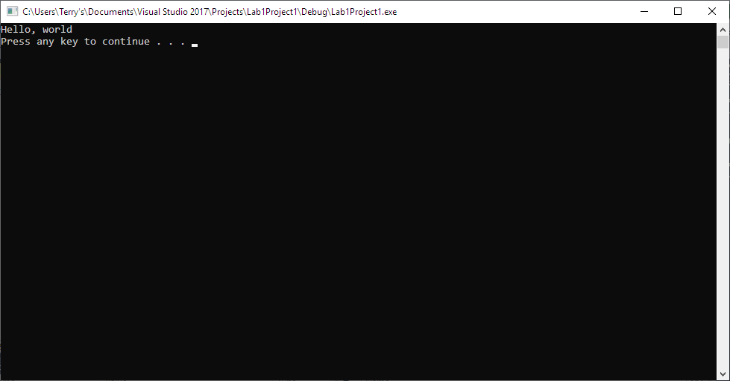

Note: To avoid additional point deductions; remember to submit both code and output.

>>>

**b)** Be sure to show completion of Security Injections by providing Screen shots of (or copy and paste) your Security Injection completion **Certificate** above**. Do not email me your certificate.**

**c) Late policy:** Late submissions will receive a zero grade. Get help during the week so that you can submit on time.